## **Схема сети**

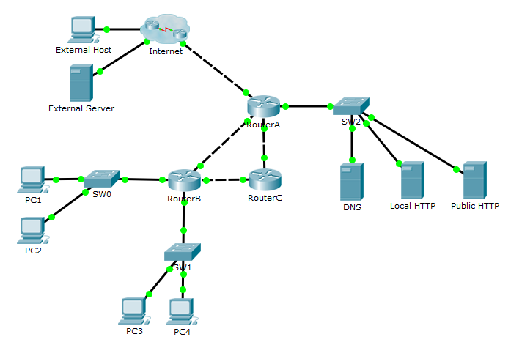

Рис. 1. Схема сети

**Расчет адресов сетей**

| **Параметр** | **VLAN A** | **VLAN B** | **VLAN C** | **VLAN D** |
| --- | --- | --- | --- | --- |
| Количество узлов | 754 | 34 | 175 | 1353 |
| Маска (префикс) | /22 | /26 | /24 | /21 |
| Маска (десятичн.) | 255.255.252.0 | 255.255.255.192 | 255.255.255.0 | 255.255.248.0 |
| Маска (инверсная) | 0.0.3.255 | 0.0.0.63 | 0.0.0.255 | 0.0.7.255 |
| SUBNET | 10.7.8.0 | 10.7.13.0 | 10.7.12.0 | 10.7.0.0 |
| BROADCAST | 10.7.11.255 | 10.7.13.63 | 10.7.12.255 | 10.7.7.255 |

**Сведения о конфигурации устройств**

| **Устр-во** | **Интерфейс** | | **IP-адрес/ VLAN** | **Маска подсети** | **Шлюз** (где необходимо) |
| --- | --- | --- | --- | --- | --- |
| Router A | fa6/0 | | 169.13.14.33 | 255.255.255.252 | - |
| fa7/0 | | 192.168.0.1 | 255.255.0.0 | - |
| fa8/0 | | 10.7.13.66 | 255.255.255.252 | - |
| fa9/0 | | 10.7.13.74 | 255.255.255.252 | - |
| Router B | fa6/0 | | 10.7.13.65 | 255.255.255.252 | - |
| fa7/0 | 1 | 10.7.8.1 | 255.255.252.0 | - |
| 2 | 10.7.13.1 | 255.255.255.192 | - |
| fa8/0 | 1 | 10.7.12.1 | 255.255.255.0 | - |
| 2 | 1.7.0.1 | 255.255.248.0 | - |
| fa9/0 | | 10.7.13.69 | 255.255.255.252 | - |
| Router C | fa6/0 | | 10.7.13.73 | 255.255.255.252 | - |
| fa7/0 | | 10.7.13.70 | 255.255.255.252 | - |
| SW0 | fa0/1 | | trunk | - | - |
| fa0/2 | | 24 | - | - |
| fa0/3 | | 25 | - | - |
| SW1 | fa0/1 | | trunk | - | - |
| fa0/2 | | 26 | - | - |
| fa0/3 | | 27 | - | - |
| PC 1 | NIC | | 10.7.11.254 | 255.255.252.0 | 10.7.8.1 |
| PC 2 | NIC | | 10.7.13.62 | 255.255.255.192 | 10.7.13.1 |
| PC 3 | NIC | | 10.7.12.254 | 255.255.255.0 | 10.7.12.1 |
| PC 4 | NIC | | 10.7.7.254 | 255.255.248.0 | 10.7.0.1 |
| DNS | NIC | | 192.168.1.2 | 255.255.0.0 | 192.168.0.1 |
| Local http | NIC | | 192.168.7.254 | 255.255.0.0 | 192.168.0.1 |
| Public http | NIC | | 192.168.8.254 | 255.255.0.0 | 192.168.0.1 |

**Сведения о настроенных ACL**

|  |  |  |  |
| --- | --- | --- | --- |
| **Устр-во** | **Интер-фейс** | **Напр. трафика (in/out)** | **Правила** |
| RouterB | fa7/0.1 | in | permit ip 10.7.8.0 0.0.3.255 any |
| permit icmp any any |
| fa7/0.2 | in | permit icmp any any |
| deny ip 10.7.13.0 0.0.0.63 10.7.8.0 0.0.3.255 |
| deny ip 10.7.13.0 0.0.0.63 10.7.12.0 0.0.0.255 |
| deny ip 10.7.13.0 0.0.0.63 10.7.0.0 0.0.7.255 |
| permit ip 10.7.13.0 0.0.0.63 any |
| fa8/0.1 | in | permit icmp any any |
| permit ip 10.7.12.0 0.0.0.255 host 192.168.7.254 |
| permit udp 10.7.12.0 0.0.0.255 host 192.168.1.2 eq 53 |
| fa8/0.2 | in | permit icmp any any |
| permit udp 10.7.0.0 0.0.7.255 host 192.168.1.2 eq 53 |
| deny ip 10.7.0.0 0.0.7.255 host 192.168.7.254 |
| deny ip 10.7.0.0 0.0.7.255 host 192.168.8.254 |
| permit ip 10.7.0.0 0.0.7.255 any |
| RouterA | fa6/0 | in | permit tcp any host 192.168.8.254 eq 80 |
| permit udp any host 192.168.1.2 eq 53 |
| permit tcp any any established |
| fa7/0 | out | permit ip 10.7.8.0 0.0.3.255 any |
| permit tcp 10.7.13.0 0.0.0.63 host 192.168.8.254 eq 80 |
| permit udp 10.7.13.0 0.0.0.63 host 192.168.1.2 eq 53 |
| deny ip 10.7.13.0 0.0.0.63 any |
| permit tcp 10.7.12.0 0.0.0.255 host 192.168.7.254 eq 80 |
| permit tcp any host 192.168.8.254 eq 80 |
| permit udp any host 192.168.1.2 eq 53 |
| deny ip 10.7.12.0 0.0.0.255 any |
| permit udp 10.7.0.0 0.0.7.255 host 192.168.1.2 eq 53 |
| permit tcp 10.7.0.0 0.0.7.255 host 192.168.7.254 eq 80 |
| deny ip 10.7.0.0 0.0.7.255 any |

**Пароли для подключения к устройствам**

|  |  |  |
| --- | --- | --- |
| **Устройство** | **Пароль обычного режима** | **Пароль привилегированного режима** |
| RouterA | A | A |
| RouterB | B | B |
| RouterC | C | C |